Edge detection

**الإسم : محمد نشأت محمد فراج  
سكشن : 3**

**Edge detection**

Matlab Code :

*I = imread('circuit.tif');*

*J = edge(I);*

*figure;*

*imshow(I);*

*firstDev = edge(J, 'prewitt');*

*figure;*

*imshow(firstDev);*

*secondDev = edge(J, 'log');*

*figure;*

*imshow(secondDev);*

*cannyAlg = edge(J, 'canny');*

*figure;*

*imshow(cannyAlg);*

original Photo

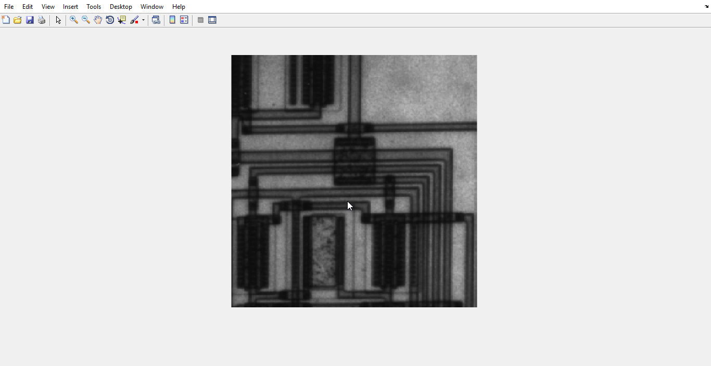

**Edge detection with first derivative:**

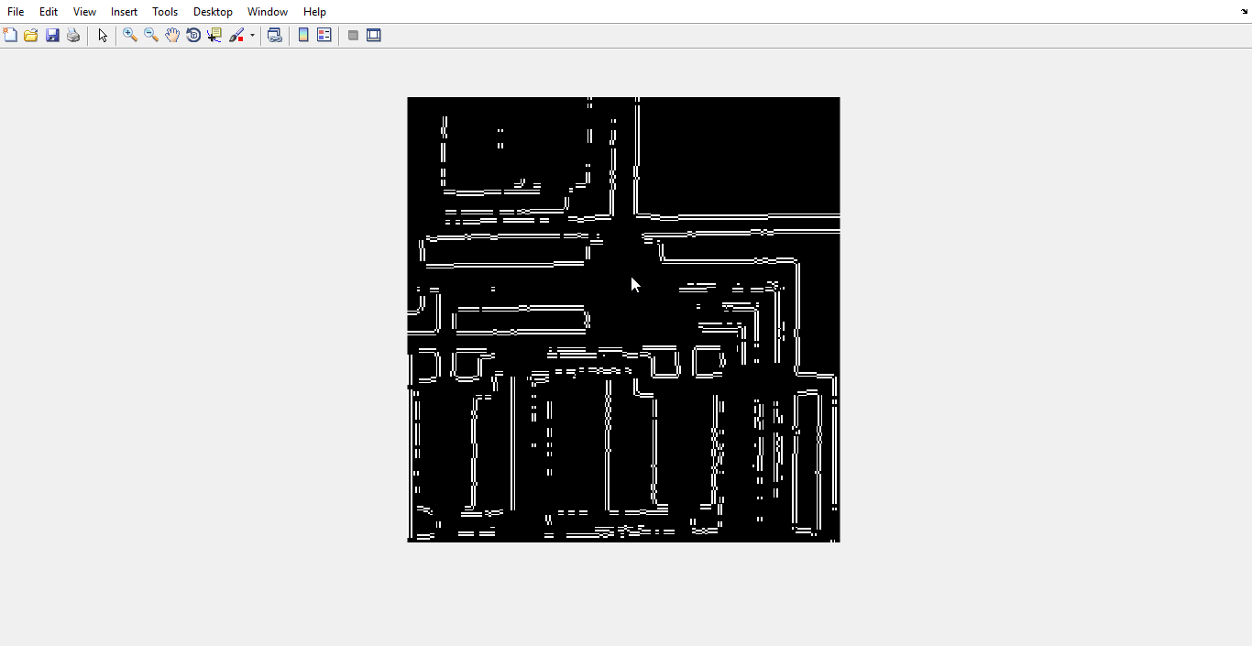

**Edge detection using Second derivative :**

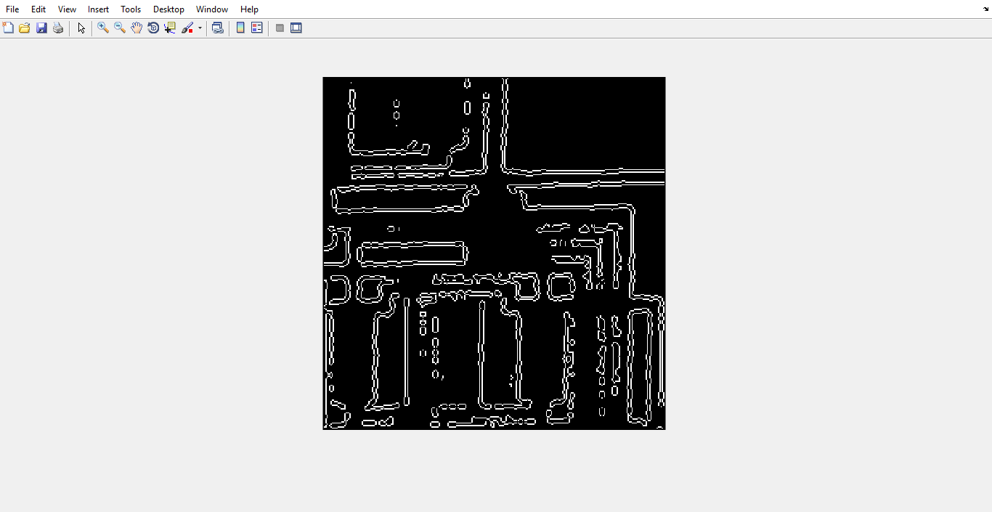

**Edge detection using canny algorithm:**

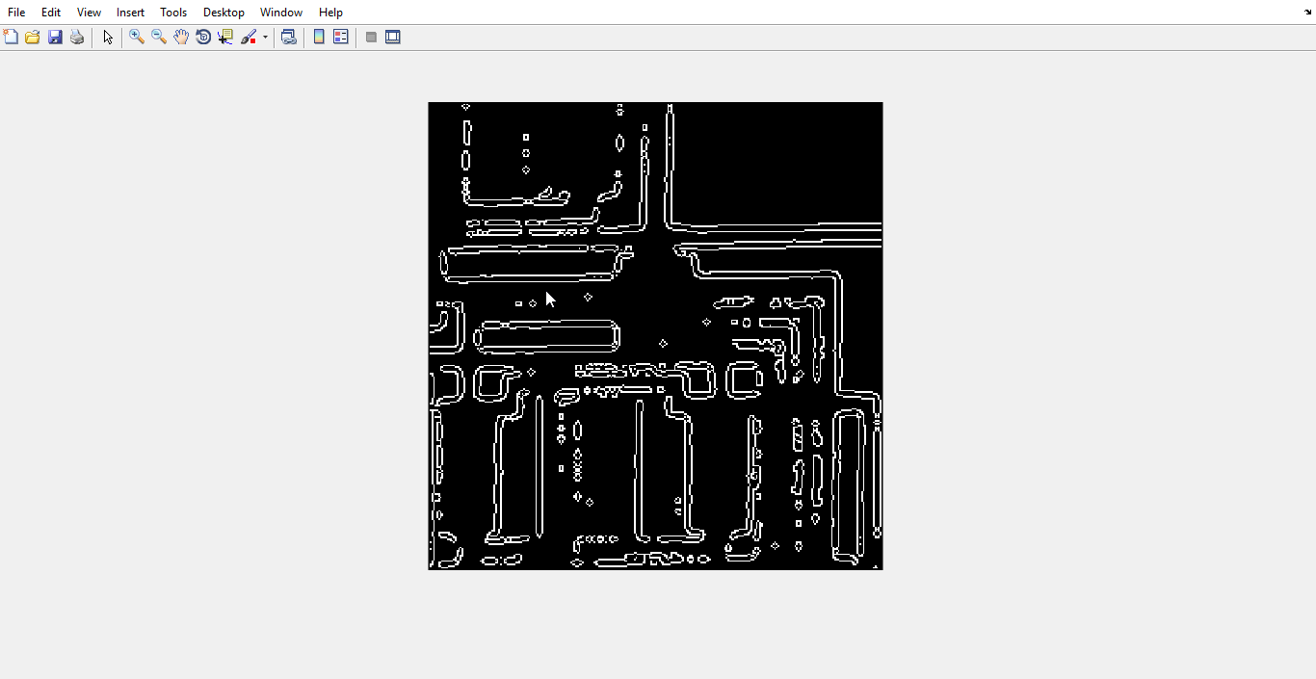

I think edge detection using canny algorithm can give us a better result